Influence of Islamic Content on Instagram Through Product Attractiveness Towards Corporate Image

Ruvira Arindita, M.Si^{1*}, Dr. Kussusanti, M.Si ², Nursalsa Arifah,S.I.Kom ³

^{1,2,3} Universitas Al Azhar Indonesia, Jakarta, Indonesia
*e-mail ruvira.arindita@gmail.com

Artikel  Submitted: xx-xx-20xx,  Revi: xx-xx-20xx,  Accepted: xx-xx- 20xx  Published: xx-xx-20xx  DOI: https://doi.org/10.32509/_diisi pengelola jurnal  This work is licensed under a Creative Commons Attribution-NonCommercial-ShareAlike 4.0.  Volume :  No. :  Bulan :  Tahun :  Halaman : | Abstract  Moslem fashion development followed by the advancement of information technology in the past years have provided the space for hijab online shop to improve. Persuasive communication with followers via social media Instagram is considered important. Moreover, competition among hijab online shops encouraged brands to build corporate image so that they look good for the public. This research aimed to know the influence of persuasive communication on the Islamic content of Hijab Online Shop’s Instagram account influence corporate image with moderation of product attractiveness.  This research uses quantitative method with positivism paradigm. The theory used is functional theory, product attractiveness and corporate image. The population of this research is followers of the three hijab online shops that are the most active in terms of posting the Islamic content, they are @vanillahijab, @alezalabel and @hijup. The sampling method was conducted purposively, with the total sample 100 people.  This research indicates that there is influence of persuasive communication in Islamic content of hijab online shop’s Instagram account towards the corporate image and the influence increases in accordance with the increase of product attractiveness. Knowledge as part of persuasive communication is the most influential aspect among other persuasive communication elements. Other than that, product attractiveness remained as supportive factor in building corporate image. Therefore, in the effort of persuading followers, persuasive communication and product attractiveness should be developed altogether.  Keywords: (bahasa inggris; 3-5 keywords) 1st word; 2nd word; 3rd word; 4th word; 5th word

INTRODUCTION
Based on data from State of Global Islamic Economic Reports 2018, in Indonesia, the moslem fashion consumption approximately reached 20 billion USD. Indonesia ranked on the second position below United Emirate Arab as the country of moslem fashion producer in the [1]. Indonesian president Jokowi proudly mentioned that every year there is 45 trillion rupiahs of national income from the moslem fashion industry. This industry is also projected to absorb new 1,1 million manpower from the total current of 3,8 million people who have in fashion industry. These numbers speak volume about the contribution of moslem fashion industry for national economy growth(Merdeka.com, 2018).
Given this prospective future and a large market of moslem fashion in the country, there are more and more online hijab stores at the present. As the effort to thrive on the tight competition on the industry, the online hijab store tried to build a good communication with consumer. Previous study noted that HIJUP have managed to build comfortable emotional relations with customer that brought up to strategic level through the twitter content of @Hijup[3]. Other famous hijab online store used the strategy of using Instagram celebrity to communicate with their customer and build the corporate image like the one did by Vanilla Hijab (Riyani, Sitanggang, Novrian, 2020). Other than that, the use of social media content in the form of picture and video with the theme of moslem and the friendship concept was used by Hijab Sally Heart to communicate and promote to their consumer. Those kinds of online content resulted in spiritual emotional involvement between online shop and their customer (Puspitasari, & Gusfa, 2017).
According to Cosmopolitan.co.id there are number of top online hijab stores in Indonesia namely HIJUP, vanilla Hijab and Alezalabel [6]. HIJUP, Vanilla Hijab dan Alezalabel presented content with Islamic values on their Instagram posts. Social media content often become one of factors used by business industry to improve their image. Kittsel dan Buttgen on their research studied about the use of social media to communicate employer branding and its effect on corporate image (Kissel, Büttgen, 2015). That study showed that self-congruency concept and information on social media did not have direct effect on product attractiveness and application intention however with the mediated variable corporate image, the effect was stronger. [8] Another earlier research also noted about positive connection between attractiveness stimuli and product quality pn certain contexts such as websites (Wang et al. 2011) and retail stores (Richardson et al. 1996).
This research is trying to fill in the gap of the previous researches. There were not many studies that discuss persuasive communication on social media content. Other studies focused more on the emotional element on twitter content [3]. Furthermore, on the research regarding online hijab stores focused more on the influence of instagram celebrity endorser towards the corporate image (Riyani, Sitanggang, Novrian, 2020). With regard to social media content so far only discuss about female moslem and friendship issue (Puspitasari, & Gusfa, 2017). Moreover, there was no previous studies that correlate social media content and product attractiveness. Thus, based on the abovementioned discussion and background, this research aims to know the connection between persuasive communications on the Islamic content on online hijab stores with the corporate image with the moderation of product attractiveness. Based on literature study, the research model and hypotheses are as follows:
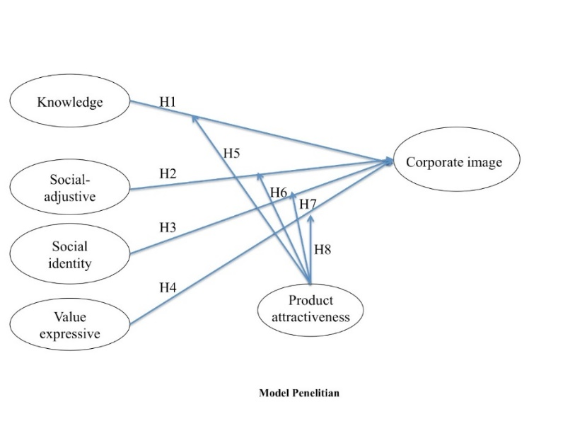

From the research model above, these following are the hypothesis of this study: (H1) Knowledge has positive effect on corporate image. (H2) Social adjustive has positive effect corporate image. (H3) Social identity has positive effect on corporate image. (H4) Value expressive has positive effect on corporate image. (H5) Knowledge has positive effect on corporate image with moderation on product attractiveness. (H6) Social adjustive has positive effect on corporate image with moderation product attractiveness. (H7) Social identity has positive effect on corporate image with moderation product attractiveness. (H8) Value expressive has positive effect on corporate image with moderation on product attractiveness.

Research Methodology
This research uses positivism paradigm that aims to have confirmation about the causal relationship. Analysis towards variables on this research is conducted by hypothetico-deductive method that is doing the hypothesis test in which the hypothesis was being deducted from another hypothesis with higher conceptual formulation. Thus, this research started with creating theoretical framework to build hypothesis as the tentative answer for the research problem tested. If positively tested, this hypothesis was perceived as facts and used to enrich the theory used.
From the “List of Best Online Shop Hijab & Modest Wear in 2018” that was released by cosmopolitan.co.id, there are six online shops with Instagram account, they are @hijup, @vanillahijab, @wearingklamby, @marionstheory, @alezalabel, @heaven_lights. From those six Instagram accounts, the three account that has Islamic contents are namely @hijup, @vanillahijab dan @alezalabel. Therefore, the population for this research is followers who give “likes” on the three Instagram accounts.
The sampling method was conducted by purposive sampling method based on respondent criteria that has been previously determined (Cooper & Schindler, 2014), they are in line with the question and purpose of the research. The criteria for respondents for this research are as follows: (1) Indonesian women without age boundaries, (2) Being follower of Instagram @hijup, @vanillahijab dan @alezalabel, (3) Giving “likes” to Instagram post with content concerning Islamic values on Instagram @hijup, @vanillahijab dan @alezalabel during the period of the last 6 months. The six months time-span was chosen to avoid recall bias (Gohary et al., 2016). The number of respondents at least four or five times indicators or
No. | Instagram Toko Busana Muslimah | Jumlah Followers | Sampel
1. | @hijup | 1.100.000 | 32
2. | @vanillahijab | 2.000.000 | 60
3. | @alezalabel | 287.000 | 8
TOTAL |  | 3.387.000 | 100
sub variables tested [11]. A number of indicators on this research is 25, so the minimum number of respondents is 4 x25 = 100 persons.

Sample Distribution Table

Data Collection Technique
Data collection on this research started with listing the sample frame according to respondent’s criteria that has been determined before: Indonesian women without age boundaries who are followers of these Instagram accounts @hijup, @vanillahijab and @alezalabel who gives “likes” to Islamic content during the past six months. After that, researcher send the questionnaire in the format of Google Form through Direct Message of respondents’ Instagram that are randomly selected for about 100 persons.
Data collected on this study is primary data that is gathered through survey method by asking questions to a number of respondents. All variables with indicators are measured by 4-point Likert-type scales, starts from strongly disagree (1) to strongly agree (4). This research uses google Docs that was sent from direct message through the Instagram to respondents. Respondents are supposed to answer the questions by clicking the options on the link provided by researchers.
Validity and Reliability Test
After the questionnaire was ready, there were pre-test conducted towards 30 respondents to test validity and reliability of questionnaire. Validity test was done by Kaiser-Meyer-Olkin Measure of Sampling Adequacy (KMO-MSA), to test whether the questions asked are valid or not to measure certain construct. An indicator was considered valid to measure the construct if the score of Barlett Test of Sphericity for all indicators are significant < 0,05, KMO-MSA score for all indicators are > 0.5, score of Anti-image Correlation – MSA > 0.5, score of communalities > 0.5 and score of component matrix > 0.5.

Data Analysis Method
Data analysis method used on this research is quantitative analysis, which includes of univariate analysis to know about respondent’s profile and Islamic content of hijab online shops as well as bivariate analysis to see the kind of and strength of relations between variables. The analysis is conducted by SPSS.

RESULT AND DISCUSSION

Respondent on this research are Instagram followers of the official account of @Hijup, @Vanillahijab and @Alezalabel. All respondent is then categorized based on age. Researchers collected data by spreading the questionnaire via google form. Below is the data about respondent’s profile:

@Hijup Instagram
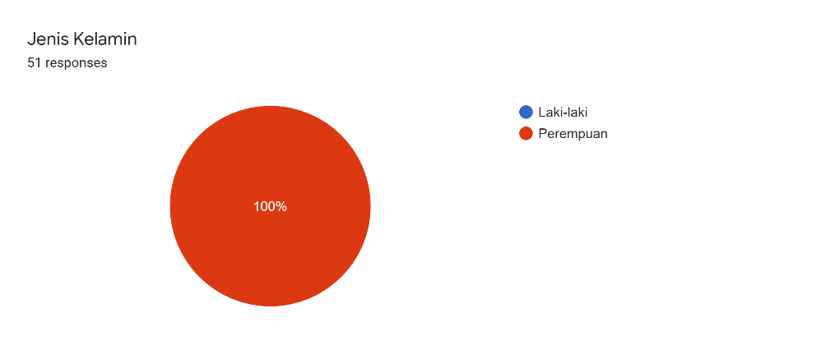
Based on diagram above, 100% of 55 respondents who are followers of @Hijup account is women. It is in the nature of the brand as muslim women fashion store

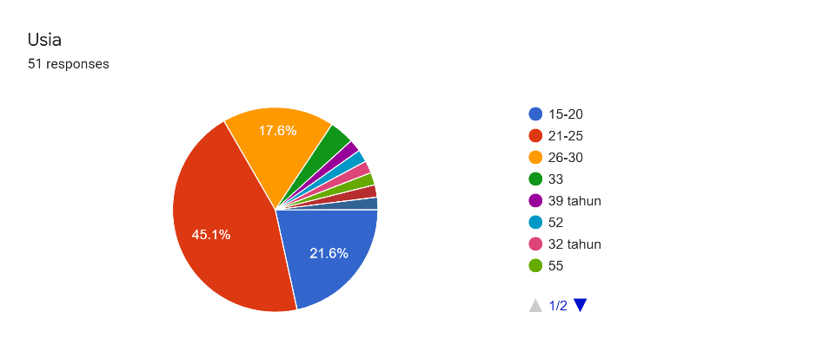

From the diagram above, we can see that majority of age group of @Hijup ‘s followers is 21-25 years, with the percentage of 45,1%. On the second place, there is 15-20 years old women or about 21,6%. The third position is 26-30 years old group with percentage of 17,6 %. While the least group are those who are 30 years and above.

@Vanillahijab Instagram
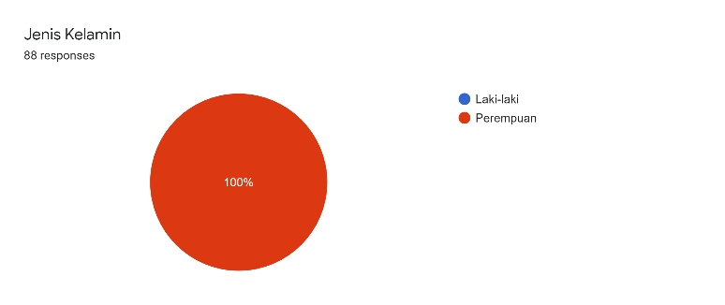

Based on survey result, 100% of 88 respondents who are followers of @Vanillahijab is women. The same as previous brand, this is in accordance with the identity of product itself, muslim women fashion therefore all the account follower is women.
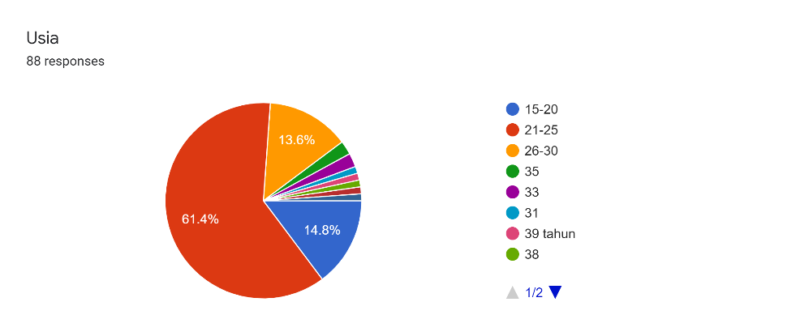

On diagram above it was noted that the dominant age group who are followers of @Vanillahijab is 21-25 years old with percentage about 61,4% of 88 respondents. And then, below this age group, there is 15-20 years old group fro about 14,8%. Slightly lesser than that, the next age group is 26-30 years old with percentage of 13,6%. The rest is respondents who are 30 years old and above.

@Alezalabel Instagram

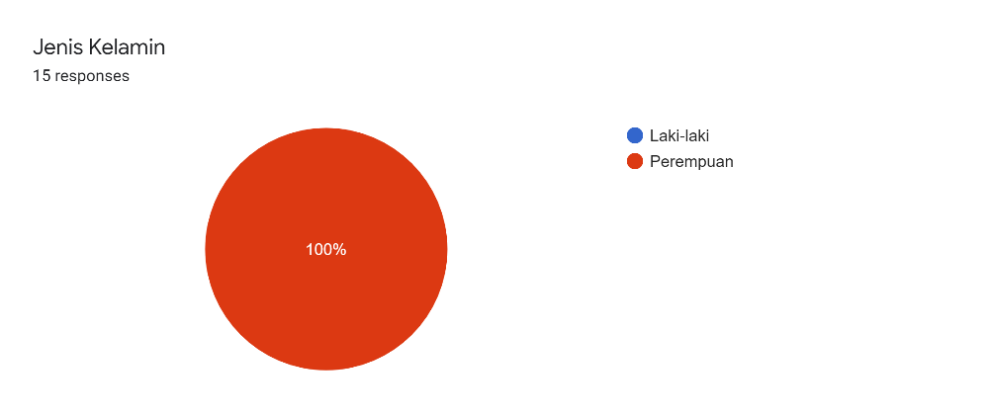
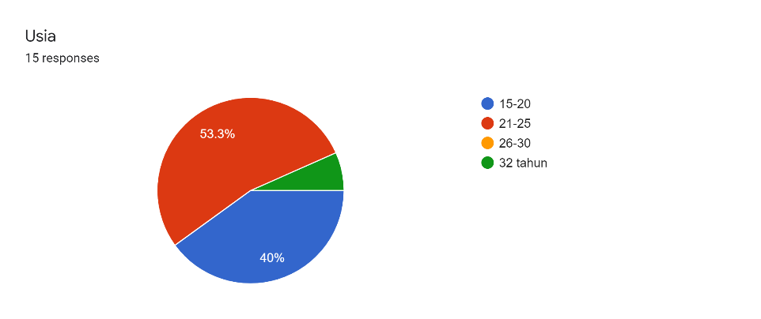
Based on the survey, 100 % of 15 respondents who are @Alezalabel’s followers are women. The same thing applied as the previous two hijab online shops, because the shop sells women fashion therefore the followers are all women.

Based on survey, the respondents who are followers @Alezalabel dominantly are those who are 21-25 years old with percentage about 53,3%. On the second place there is group age 15-20 years old with percentage of 40%. While the rest of the respondents are 32 years old or about 6,7%.

Bivariate Data Analysis
This analysis is conducted by using two statistics analysis methods: Pearson correlation to see the correlation between independent and dependent variables, as well as simple linier regression analysis to see the influence of independent variables towards dependent variables. Independent variables on this research are Knowledge (X1), Social Adjustive(X2), Social Identity (X3) dan Value Expressive (X4). Meanwhile dependent variable is Corporate Image (Y).

Correlation analysis
Below is the table of correlation test between variable X and variable Y:
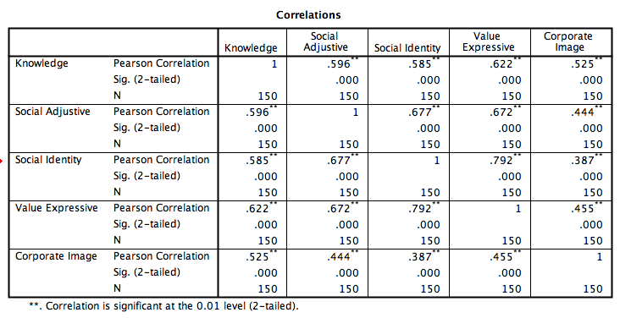

The coefficient correlation score shows the number of 0,525 for Knowledge variable, 0.444 Social Adjustive variable, 0,387 for Social Identity variable and 0.455 for Value Expressive variable. All has significance score 0.000 or lesser than 0.05. This shows that there is significant positive correlation between the for independent variables, they are Knowledge, Social Adjustive, Social Identity with dependent variable which is Corporate Image. Meanwhile the strength of correlations is not too high, it is only 0,387 up to 0.525.

Simple Linier Regression Analysis
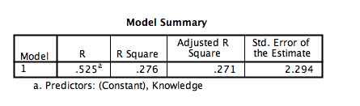
1. The influence of Knowledge towards Corporate Image

Coefficient determinant score of R Square (R²) = 0,276 indicates that independent variable of Knowledge is able to explain or predict the score of dependent variable score of Corporate Image for about 27%. The other, 73% are explained by other factors than Knowledge variables or other variables outside the research scope.
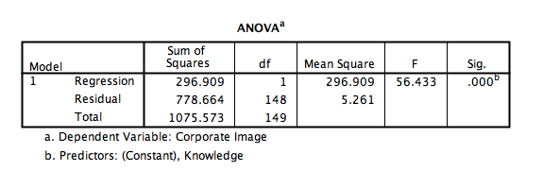

From this table, it can be seen that the score of F counted is about 56,433 with significance of 0,000. The score of significance test is < 0,05, then the regression model can be used to predict the variable of Corporate Image. In other words, there is influence of variable Knowledge toward dependent variable Corporate Image.
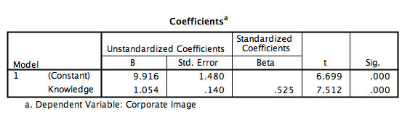
The table above displays that the constant coefficient score is 9,916. This indicates that if there is no Knowledge element on persuasion communication, then the score of consistency of Corporate Image is 9,916. Meanwhile the regression coefficient score is about 1,054 which indicates that for every extra 1% of Knowledge element in persuasion communication then the Corporate Image will raise for about 1,054.
The significance number of 0.000 is below 0.05 which means that there is influence of Knowledge variable towards Corporate Image, thus it can be concluded that H1 is accepted. There is positive influence of Knowledge towards Corporate Image.

2. The Influence of Social Adjustive towards Corporate Image

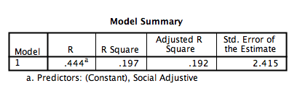

The coefficient determinant score R Square (R²) = 0,197 shows that the independent variable of Social Adjustive can explain or predict the dependent variable of Corporate Image for about 19%. The rest is explained by other factors than Social Adjustive or other variables outside the research scope.
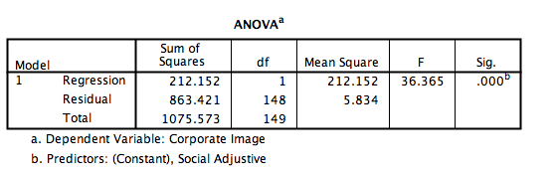

From this table, the F counted score is 36,365 with significance 0,000. The significance test score is < 0,05, therefore the regression model is able to predict the Corporate Image variable. In other words, there is influence of independent variables Social Adjustive towards dependent variables of Corporate Image.
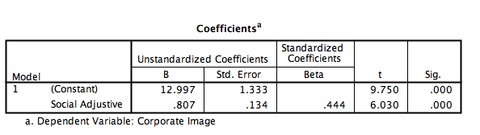

This table indicates the score of constant coefficient is 12,997. This shows that if there is no Social Adjustive element on persuasion communication, then the score of consistency of Corporate Image is 12,997. Meanwhile regression coefficient 0,807 which shows that for every addition of 1% of Social Adjustive in persuasion communication, then the Corporate Image will improve for about 0,807.
The significance score is 0.000 which is less than 0.05 means that there is influence of Social Adjustive towards Corporate Image, therefore it be summarized that H2 is accepted, there is positive influence of Social Adjustive towards Corporate Image.

3. The Influence of Social Identity Towards Corporate Image
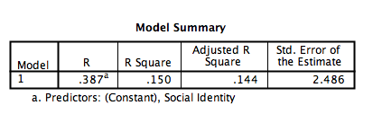

The coefficient determinant score of R Square (R²) = 0,150 shows that independent variable of Social Identity can explain or predict the dependent variable of Corporate Image for 15%. The rest is explained by other factors than Social Identity on persuasive communication or by other variables that are out of the scope of this research. S
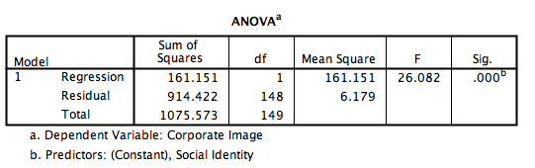
From the table above we can see that the score F counted is 26,082 with significance number. Because the significance test is < 0,05, then the regression model can be used to predict quality variable of Corporate Image, or we can also say that there is influence of Social Identity variable towards dependent variable Corporate Image.
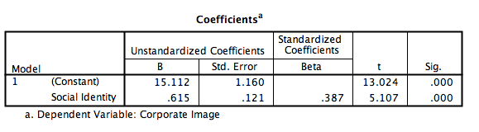

This table displays the constant coefficient score is 15,112. The number indicates that if there is no element of Social Identity on persuasion communication then the consistency score of Corporate Image is 15,112. Meanwhile, the score of regression coefficient is 0,615 which says that for every 1% addition of Social Identity element on persuasion communication, Corporate Image will improve for 0,615.
The significant score 0.000 is less than 0.05 which means that there is influence of Social Identity towards Corporate Image. Then it can be concluded that H3 is accepted. There is positive influence of Social Identity towards Corporate Image.

4. The Influence of Value Expressive Towards Corporate Image
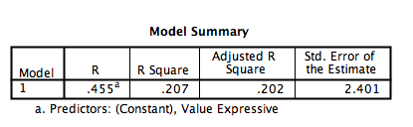

The coefficient Nilai koefisien determinasi R Square (R²) = 0,207 shows that independent variable Value Expressive can explain or predict score of dependent variable Corporate Image for 20%. The other 80% was explained by other factors than Value Expressive on persuasive communication or other variable outside the scope of research model.

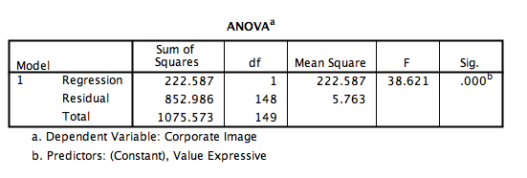

From this table the F counted score is 38,621 with significance number 0,000. Because the significance score is < 0,05, then the regression model can be used to predict quality of dependent variable of Corporate Image, or it can be said that there is influence of independent variable Value Expressive towards dependent variable Corporate Image.
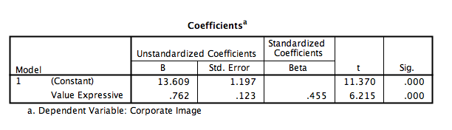

On this table the constant coefficient score is s 13,609. This number indicates that if there is no Value Expressive element on persuasive communication, the consistency score of Corporate Image is 13,609. Meanwhile, the regression coefficient score is 0,762 shows that for every 1% additional element of Value Expressive in persuasive communication then the Corporate Image will improve for 0,762.
The significance score 0.000 is less than 0.05 means that there is influence of Value Expressive towards Corporate Image. Therefore, it can be concluded that H4 is accepted. There is positive influence of Value Expressive towards Corporate Image.

Multivariate analysis
Multivariate analysis on this research uses the double linier regression with moderation or usually called moderated regression analysis (MRA). Moderated regression analysis is done to know if the moderating variable Product Attractiveness (Z) will strengthen or weaken the influence between independent variables Knowledge (X1), Social Adjustive (X2), Social Identity (X3) dan Value Expressive (X4) towards dependent variables Corporate Image (Y). Below is the result of moderated regression analysis:

1. Product Attractiveness (Z) as moderation variable on the influence of variable Knowledge (X1) towards Corporate Image (Y).

The Result of Determination Coefficient - Moderated Regression Analysis
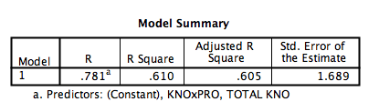

The score of Nilai Adjusted R Square is 0,605 which means that 60,5% of determination coefficient is used to know how much percentage of influence of variable X1, variable Z and moderating variable (X1xZ) towards Corporate Image (Y). Meanwhile the rest 39,5% is explained by other factors outside the scope of this research.

The Result of Simultaneous Significance Test (F Statistical Test)

F Statistical Test - Moderated Regression Analysis
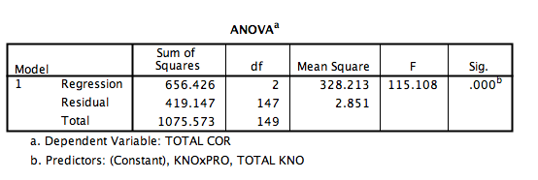

Anova Test or F test resulted in Counted F score 115,108 with significance level 0,000. Because the probability of significance is much lesser than 0,05 then the regression model can be used to predict Y. It can also be said that variable X1 and variable Z are altogether influential towards Y.

The Individual Parameter Significance Test (Statistical T Test)

Statistical T test - Moderated Regression Analysis

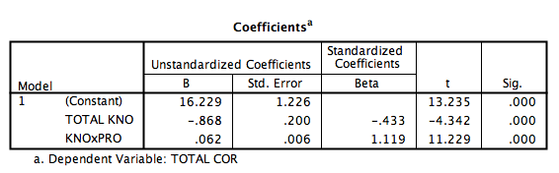

Moderating variable X1xZ which are interaction between X1 and Z gives coefficient parameter 0,062 with significance 0,000 (< 0,05). Thus, it can be concluded that Product Attractiveness variable is moderating variable that strengthen the influence of Knowledge variable towards Corporate Image. Therefore, Hypothesis 5 is proven, that the influence of Knowledge (X1) towards Corporate Image (Y) is improving as the Product Attractiveness improved (Z)

2. Product Attractiveness (Z) as the moderating variable on the influence of variable Social Adjustive (X2) towards Corporate Image (Y).

Determinant Coefficient Result
Table of Determinant Coefficient Test Result - Moderated Regression Analysis
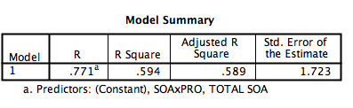

The score of Adjusted R Square is 0,589 which means that 58,9% of determinant coefficient is used to know how much the percentage of influence of variable X2, variable Z and moderating variable (X2xZ) towards the variable of Corporate Image (Y).While the remaining 41,1% is explained or influenced by other factors not included on this research.

The Result of Simultaneous Significance Test (F Statistical Test)

F Statistical Test Table - Moderated Regression Analysis
- Moderated Regression Analysis
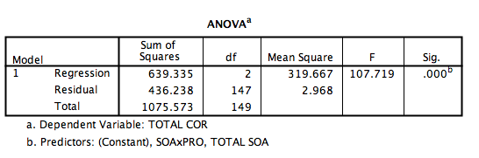

Anova or F test resulted in F counted score 107,719 with significance 0,000. Because the probability of significance is much lesser than 0,05 then the regression model can be used to predict Y. It can also be said that X2 and variable Z both influence the variable Y.
The Individual Parameter Significance Test (Statistical T Test)

T Statistical Test Result - Moderated Regression Analysis
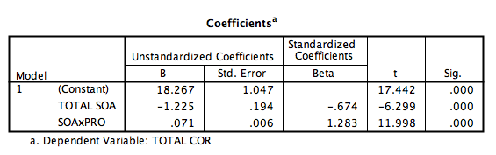

Moderating variable X2xZ which is interaction between X2 and Z are giving the parameter coefficient about 0,071 with significance less than 0,000 (< 0,05). Therefore, it can be concluded that the variable of Product Attractiveness is moderating variable that strengthen the influence of Social Adjustive towards Corporate Image. Thus, Hypothesis 6 is accepted. The influence of Social Adjustive (X2) towards Corporate Image (Y) is inclining as the Product Attractiveness (Z) inclined.

3. Product Attractiveness (Z) as moderating variable on the influence of variable Social Identity (X3) towards Corporate Image (Y).

Table of Determinant Coefficient Test Result - - Moderated Regression Analysis
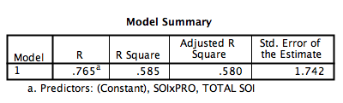

Adjusted R Square score is 0,580 which means that 58% of determinant coefficient is used to know how much the percentage of influence of variable X3, variable Z dan moderating variable (X3xZ) towards variable of Corporate Image (Y). Meanwhile the other 42% is explained by other factors outside the research.

The Result of Simultaneous Significance Test (F Statistical Test)

Table of F Statistical Test Result - Moderated Regression Analysis
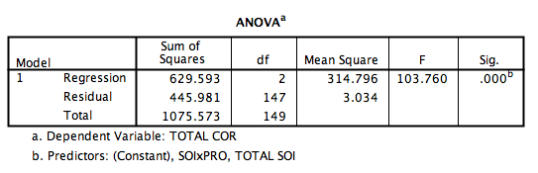
Anova or F test resulted in F counted score 103,760 with significance 0,000. Since the probability of significance is much lesser than 0,05 then the regression model can be used to predict Y. In other words, variable X3 and Z are altogether influential towards Y.

The Individual Parameter Significance Test (Statistical T Test)

Table of Statistical T Test Result - Moderated Regression Analysis
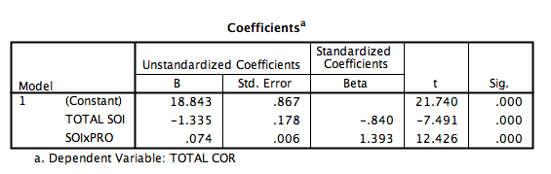

Moderating variable X3xZ which is interaction between X3 and Z gives parameter coefficient 0,074 with significance 0,000 (< 0,05). Therefore, it can be summarized that variable Product Attractiveness is moderating variable that strengthen the influence of variable Social Identity towards Corporate Image. Therefore, Hypothesis 7 is proven. The influence of Social Identity (X3) towards Corporte Image (Y) is improving as the Product Attractiveness (Z) improved.

4. Product Attractiveness (Z) as moderating variable on the influence of Value Expressive (X4) towards Corporate Image (Y).

Table of Determinant Coefficient Test Result - Moderated Regression Analysis
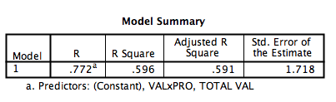

Adjusted R Square score is 0,591 which means that 59% of determinant coefficient is used to know how much percentage of influence of variable X4, variable Z and moderating variable (X4xZ) toward the variable of Corporate Image (Y). Meanwhile the rest (100% - 59%) 41% is explained or influenced by other factors outside the research.

The Result of Simultaneous Significance Test (F Statistical Test)

Table of F Statistical Test Result - Moderated Regression Analysis
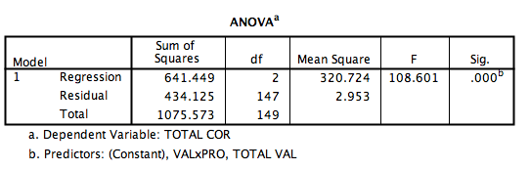

Anova or F test resulted in F counted score 108,601 with significance 0,000. Because the significance probability is much smaller than 0,05 then the regression model can be used to predict variable Y. In other words, X4 and variable Z both influence variable Y.

The Individual Parameter Significance Test (Statistical T Test)

Table of Statistical T Test Result - Moderated Regression Analysis
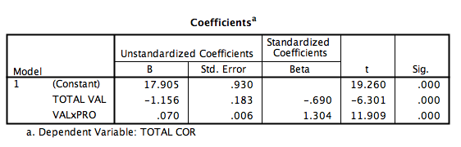

Moderating variable X4xZ which is the interaction between X4 and Z gives parameter coefficient score 0,070 with significance 0,000 (< 0,05). Therefore, it can be summarized that variable Product Attractiveness is moderating variable which strengthen the influence of variable Value Expressive towards Corporate Image. Thus Hypothesis 8 is accepted. The influence of Value Expressive (X3) towards Corporate Image (Y) is improving as the Product Attractiveness (Z) improved.

Interpretation
Based on the analysis above, the eight hypotheses proposed on this research have been proved. First, the independent variable of Knowledge (X1) can explain or predict the score of dependent variable Corporate Image for 27%. The T test result indicated that there is influence of Knowledge towards Corporate Image. Thus, it can be concluded that H1 is accepted. There is positive influence of Knowledge towards.
This result is in accordance to earlier research of Sharma and Chan (2017) that the function of Knowledge in helping consumer to organize and categorize their world in meaningful and consistent action to provide orderliness, clarity and consistency on their reference frame of work. Bettman, Luce & Payne (1998) also said that customer with better knowledge usually have better criteria in their decision and evaluation with regards to various contexts. On this case, knowledge on persuasive message in relation with Islamic values displayed on the Instagram of hijab online shops have positive influence toward the corporate image of hijab online shops.
Secondly, the independent variable of Social Adjustive (X2) can explain or predict the score of dependent variable Corporate Image for 19%. The result of T test shows that there is influence of Social Adjustive towards Corporate Image. Therefore, it can be concluded that H2 is accepted. There is positive influence of Social Adjustive towards Corporate Image.
The statement above is in line with previous study of Sharma and Chan (2017) which noted that the attitude that run the function of social adjustive can help people to keep the social relations and getting the approval from others on social situation. On the context of persuasive message on Islamic value content on the Instagram of hijab online shops, followers who agree to have social adjustive in terms of attitude with the content tend to give a more positive judgment towards corporate image of hijab online shops.
Thirdly, the independent variable of Social Identity (X3) can explain or predict the score of the dependent variable Corporate Image for 15%. The significance score 0.000 is smaller than 0.05. It means that there is influence of Social Identity towards Corporate Image,. It can be said that H3 is accepted. There is positive influence of Social Identity towards Corporate Image.
The explanation about Social Identity according to Perloff (2017) is that people are holding certain attitude to communicate who they are, what their goal and purposes. This could be their reason why people purchase certain product, by showing their association with that product they can communicate something special about themselves. With regards to this study, what was adopted was the behavior that are in accordance with Islamic values on the content. That could affect the perception of followers regarding corporate image. One of the indicators of corporate image that has closest relations with social identity is personality (Nguyen dan Bodoh , 2014)
Fourth, the independent variable of Value Expressive can explain or predict the dpendent score of variable Corporate Image for 20%. The result of T test score indicates that there is influence of Value Expressive towards Corporate Image. Then it can be summarized that H4 is accepted. There is positive relations of Value Expressive towards Corporate Image.
The statement above is correlated with what have been mentioned by Sharma and Chan (2017) that value-expressive or expressing values would help customer to showcase their primary values and self-concept towards people around them. On this research, the value-expressive seen is how followers are expressing their values based on Islamic content posted on Instagram of hijab online shops. It was shown that the value expressive displayed by followers positively influence towards the creation of corporate image for 20%. The indicators of corporate image that are related most closely with value expressive was value or ethics. The message posted on hijab online shop Instagram feeds indicates that the shop considered Islamic values are important to communicate to their followers, as they are also matter to the company.
Fifth, 60,5% of determination coefficient was used to know how much the percentage of variable knowledge X1, variable product attractiveness Z and moderation variable (X1xZ) towards variable of Corporate Image (Y). The parameter coefficient score is 0,062 with significance level 0,000 (< 0,05). Thus, it can be concluded that variable Product Attractiveness has strengthened the influence of variable Knowledge towards Corporate Image. Consequently, Hypothesis 5 is proven. The influence of Knowledge (X1) towards Corporate Image (Y) is improving as the Product Attractiveness (Z) is improved.
From the explanation above, it can be connected with previous study of Stapel (2007) with regards to product attractiveness in Schnurr, Sperdin and Sauer (2017) that said that cognitive access can explain a situation in which followers use information in accordance with context to interpret and evaluate target stimulus. The easier cognitive information is accessed, then the information would be more easily influence target’s perception. With regards to this research, the cognitive access is in the form of message of Islamic content on the Instagram feeds of hijab online shop can easily build perception of followers about corporate image. On this context, the corporate image indicator that correlates the most is corporate value and culture that are reflected on the Instagram posts with Islamic nuance.
Sixth, 58,9% of determinant coefficient is used to know how much percentage of influence of variable X2, variable Z and moderation variable (X2xZ) towards variable Corporate Image (Y). The parameter coefficient score is 0,071 with significance 0,000 (< 0,05). Thus, it can be said that Product Attractiveness is moderating variable that strengthen the influence of Social Adjustive towards Corporate Image. Accordingly, Hypothesis 6 is accepted. The influence of Social Adjustive (X2) towards Corporate Image (Y) is improving as the Product Attractiveness (Z) is improved.
Based on discussion above, social adjustive has played great role in building information context. When follower is having attitude adjustment based on Islamic content of hijab online shop Instagram, then the context developed is Islamic value and culture on their daily life. According to Stapel (2007) in Schnurr, Sperdin and Sauer (2017), information context can be used as the interpretation frame that will help target to create perception towards the same direction as the context, assimilation effect will emerge. This will enable the corporate image to be built especially from the indicators of value and culture.
Seventh, 58% of determinant coefficient is used to know how much the percentage of influence of variable of Social Identity (X3), variable Product Attractiveness(Z) and moderation variable (X3xZ) towards variable of Corporate Image (Y). Moderation variable X3xZ which are the interaction between Social Identity and Corporate Image gives parameter coefficient score 0,074 with significance 0,000 (< 0,05). Thus, it can be concluded that Product Attractiveness is moderating variable that strengthened the influence of Social Identity towards Corporate Image. Consequently, Hypothesis 7 is proven. The influence of Social Identity (X3) towards Corporate Image (Y) is improving as Product Attractiveness (Z) is improved.
Earlier study from Angier (2000) noted that male use handphone to “promote decency, status and their attractiveness towards female”. Currently, iPhone and smartphone have also played role as essential social identity for young adult that can be considered as the “extension of the hand rather than merely tools” (Lovett, 2014). Those two previous studies are in accordance with this current research. Social identity that is formed through the self-adjustment with the persuasive message on Islamic content on Instagram of hijab online shop, its influence is getting stronger if being moderated with product attractiveness. With the adjustment of self-identity based on Islamic content and belief about product attractiveness, the women who are followers of Instagram of these hijab online shops would present themselves as Muslimah whose attitude is in accordance with Islamic norms. This positively relates with the evaluation from followers with perception of followers about product quality, service, corporate social responsibility as well as value and culture of hijab online shops.
Eights, 59% of determinant coefficient is used to know how much percentage of influence of Value Expressive, product attractiveness and moderation variable (X4xZ) towards variable of Corporate Image (Y). The coefficient parameter is 0,070 with significance 0,000 (< 0,05). Then it can be concluded that Product Attractiveness is moderating variable that strengthen Value Expressive towards Corporate Image. Therefore, Hypothesis 8 is accepted. The influence of Value Expressive towards Corporate Image is improving as there is improvement in Product Attractiveness.
The influence of Value expressive on persuasive message on Islamic content on hijab online shops towards Corporate Image is improving as product attractiveness is improved. This is in accordance with what Perloff (2017) mentioned that everyone has certain attitude to express values and belief. With regards to this research, the statement of Value Expressive that has highest agreement form the followers is that they follow the attitude suggestion based on the Islamic content on the Instagram of hijab online shops because they are in line with their consciences. The variable product attractiveness especially about the physical product that looks appealing will strengthen Value Expressive towards Corporate Image.

Conclusion
There are eight hypotheses on this research and all of them is proven and accepted. Although the influence is relatively weak, there is positive influence of knowledge, social adjustive, social identity and value expressive towards corporate image. However, with the moderation variable product attractiveness, the influence is getting much stronger. This result suggests that the persuasive message on the Islamic content of hijab online shop’s Instagram account have influence towards corporate image of respective hijab online shops (Hijup, Vanilla Hijab and Aleza Label). Nonetheless, the Islamic content alone is not enough to boost the corporate image. Product attractiveness still plays great role in influencing a more positive perception regarding corporate image. Therefore, these two factors should be taken seriously as both have significant influence over corporate image of hijab online shops.
Suggestion
On academic front, this research has proven that persuasive message of Islamic content on Instagram have influence in corporate image. Yet, the influence was much stronger when moderated with product attractiveness. This suggests that the next research could analyze further about persuasive message with other kind of content that may give stronger influence towards corporate image.
For the business side, hijab online shops can keep exploring creative ways in presenting persuasive message with Islamic content because this variable is proven to have influence in creating corporate image. Hijab online shops should also maintain product attractiveness as this was proven to strengthen the influence of persuasive message towards corporate image significantly.

References
A. Nursalikah, “Indonesia aims at becoming global Muslim fashion capital,” Republika, 2019.
“5 Kehebatan Bisnis Busana Muslim Indonesia di Dunia,” Merdeka, 2018.
P. Athia, “Narrative Study of Emotion Marketing: The Uses of Twitter At @Hijup,” J. Bus. Manag., vol. 9, no. 2, pp. 62–73, 2013, [Online]. Available: www.iosrjournals.org.
N. Riyani, A.D., Sitanggang, O.A., “Pengaruh Selebgram Endorser Online Shop Di Instagram Terhadap Citra Perusahaan Vanilla Hijab,” pp. 41–54, 2020, [Online]. Available: http://repository.ubharajaya.ac.id/id/eprint/5636.
Puspitasari, F., & Gusfa, “Strategi Promosi Online Shop Melalui Sosial Media Dalam Membangun Brand Engagement,” Mediakom J. Ilm. Ilmu Komun., vol. 7, no. 2, pp. 115–130, 2017, [Online]. Available: https://publikasi.mercubuana.ac.id/index.php/mediakom/issue/view/292.
K. Calesta, “Daftar Online Shop Hijab & Modest Wear Terbaik 2018,” Cosmopolitan.co.id, 2018.
M. Kissel, P., Büttgen, “Using social media to communicate employer brand identity: The impact on corporate image and employer attractiveness,” J. Brand Manag., vol. 22, no. 9, pp. 755–777, 2015.
N. Schnurr, Benedikt & Brunner-Sperdin, Alexandra & Stokburger-Sauer, “The effect of context attractiveness on product attractiveness and product quality: the moderating role of product familiarity,” Mark. Lett., vol. 28, no. 2, pp. 241–253, 2017, doi: https://www.researchgate.net/deref/https%3A%2F%2Flink.springer.com%2Farticle%2F10.1007%2Fs11002-016-9404-3.
R. M. Perloff, The Dynamics of Persuasion Communication and Attitudes in the 21st Century, Sixth. New York, 2017.
S. Harrison, Marketers Guide To Public Relations. New York, 2005.
N. . Malhotra, Marketing research, an applied orientation, 6th Editio. New Jersey: Pearson Education, Inc., 2010.

